

**Unit 4 Human Biology**

**Hominin Evolution Test**

**Structure:**

**SECTION A MULTIPLE CHOICE 15 MARKS**

#### SECTION B SHORT ANSWER 30 MARKS

**SECTION C EXTENDED ANSWER 10 MARKS**

**TOTAL 55 MARKS**

### Section 1: Multiple Choice (15 marks)

1. The diagram below shows bones from the foot of four primates, which one is human? Circle your choice.

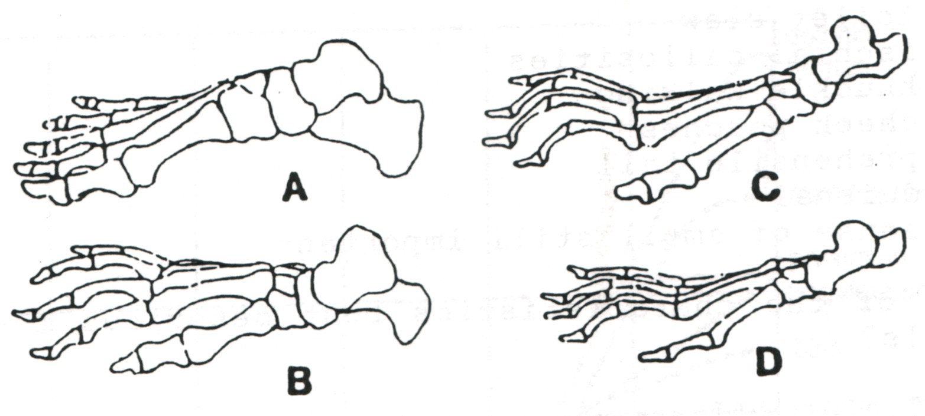

The evolutionary pathways of seven living primates are shown below.

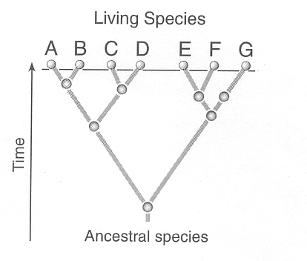

2. Which two species are likely to have the most similar DNA base sequences?

1. B and G.
2. E and G.
3. C and D.
4. B and C.

3. The pelvis, femur and knee joint of Hominins assist them to walk bipedally.

Which of the following enables this to happen?

(a) The femurs produce a carrying angle as a consequence of a wider pelvis.

(b) Weight transmission falls inside the femur to the knee joint.

(c) The femur is lengthened to raise the centre of gravity of the body.

(d) The hip sockets are close together to increase stability.

4. Consider the following diagrams of Hominin skulls. The correct sequence of evolution, from oldest to youngest, of the Hominin species shown is

specimen 1 specimen 2 specimen 3



(a) 2, 3, 1

(b) 3, 1, 2

(c) 1, 2, 3

(d)2, 1, 3

5. There is evidence that two Hominins *Homo sapiens* and *Homo neanderthalensis* coexisted in Europe more than 30 000 years ago. Both of these species left signs of cultural evolution from this period. An example of evidence which would show that cultural evolution was occurring in these groups at this time is

(a) drawings and carvings on rocks.

(b) animal remains close to a *Homo* skeleton.

(c) male and female skeletons in the same area.

(d) *Homo sapiens* and *Homo neanderthalensis* skeletons in the same area.

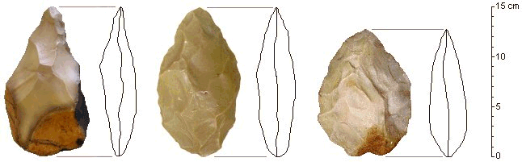6. Look at the pictures below

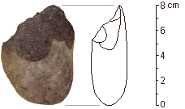

A B

Which of the following statements is correct for the tools shown above?

1. Tool A was produced by a hominin and is older than Tool B which was made by Homo erectus.
2. Tool A was used by women because it is smaller than Tool B which was used by men.
3. Tool A is more finely worked than Tool B and was often attached to pieces of wood to form stone axes.
4. Tools A and B are made from the flakes chipped from the core of stone.

7. Consider the following diagram of skulls.



The skull most likely to be that of a chimpanzee is:

1. W.
2. X.
3. Y.
4. Z.

8. The cultural hallmarks of the Neanderthals are:

(a) Agriculture.

(b) Mousterian tools.

(c) Language.

(d) An enlarged cranial capacity.

**The next question refers to the list of features below**

1. an S-shaped curvature of the spine
2. both transverse and longitudinal arches in the foot
3. a prehensile foot
4. brain size of 400-500 cubic centimetres
5. a centrally-placed foramen magnum

9. Which of the above features are characteristic of hominins but **NOT**

(apes)?

1. i, iii and iv only
2. ii, iv and v only
3. i and v only
4. i, ii and v only

Consider the diagrams below:



10. Which of the following would be the most likely evolutionary sequence towards *Homo sapiens*?

(a) D --> A --> C --> B.

(b) A --> B --> C --> C.

(c) D --> C --> A --> B.

(d) B --> D --> C --> A.

**The next three questions refer to the diagram of early hominid tools shown below. These tools are not drawn to scale.**

TOOL A TOOL B

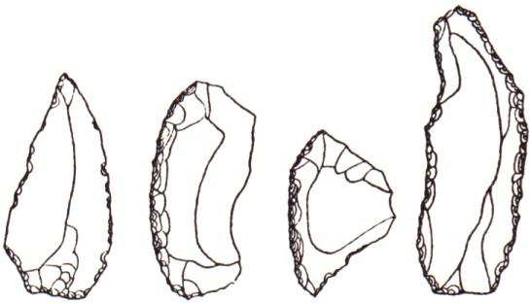

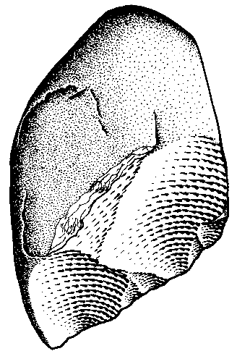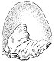

TOOL C TOOL D

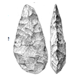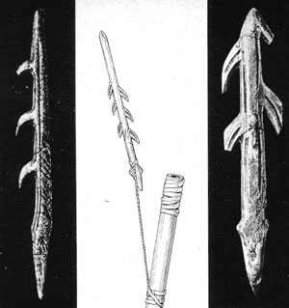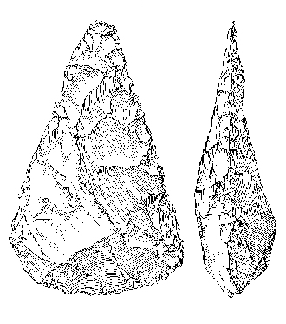

11. With which hominid do you associate tool **C**?

1. The Australopithecines only
2. The Australopithecines and Homo erectus.
3. Homo habilis and Homo erectus.
4. Homo erectus.

12. What is the relative date for tool **A**?

1. Tool A is the oldest of the tools shown.
2. Tool A is the youngest of the tools shown.
3. Tool A is older than tool D but younger than tool B and C.
4. Tool A is older than tools B and C but younger than tool D.

13. Which of the following statements concerning these tools is correct?

1. All these tools can be dated to an absolute date.
2. Tool C is associated with the emergence of fire.
3. Tool B would be found alongside tools made of bone and antler.
4. Major finds of tool A occurred in east Africa.

14. Which characteristics are **unique** to hominins?

1. An opposable thumb and stereoscopic vision.
2. A well-developed cerebral cortex and a reduced snout and sense of smell.
3. An upright stance and prehensile feet.
4. An upright stance, highly manipulative hands and a well-developed brain.

15. Compare the diagram of the feet below of an ape and a human.

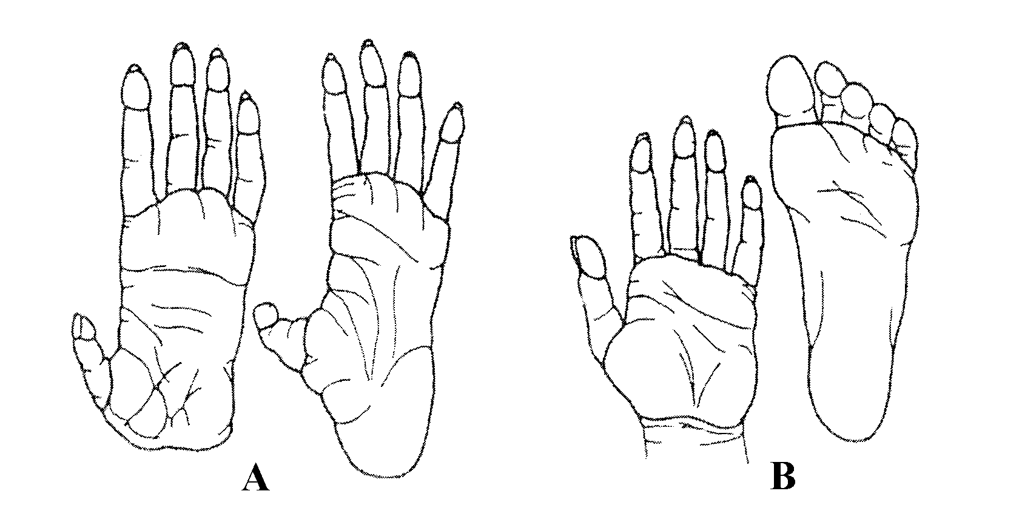

The feet shown in picture (B) have changed over time to enhance bipedalism by:

1. having two arches, loss of prehensility and a larger big toe.
2. having one arch, loss of prehensility and a larger big toe.
3. having two arches, gain of prehensility and a larger big toe.
4. having two arches, loss of prehensility and a smaller big toe.

MULTIPLE CHOICE ANSWER SHEET

NAME _________________________________________________________

Use pencil to mark a cross **X** in the box that represents the best choice. Read each question carefully

|  |  |  |  |  |
| --- | --- | --- | --- | --- |
| **QUESTION** | **Choose One Alternative** | | | |
| 1 | a | b | c | d |
| 2 | a | b | c | d |
| 3 | a | b | c | d |
| 4 | a | b | c | d |
| 5 | a | b | c | d |
|  |
| 6 | a | b | c | d |
| 7 | a | b | c | d |
| 8 | a | b | c | d |
| 9 | a | b | c | d |
| 10 | a | b | c | d |
|  |
| 11 | a | b | c | d |
| 12 | a | b | c | d |
| 13 | a | b | c | d |
| 14 | a | b | c | d |
| 15 | a | b | c | d |

### Section 2: Short Answer (30 marks)

**Question 16 (4 marks)**

Complete the table below matching the hominin group with a feature most likely to be associated with them. (Some groups may be used multiple times, some not at all)

A Paranthropus robustus

B Homo erectus

C Homo habilis

D Homo sapiens

E Australopithecus africanus

F Australopithecus aferensis

G Homo neanderthals

|  |  |
| --- | --- |
| Hominin group (letter) | Hominin defining feature |
| B | First use of fire |
| B | First constructed dwellings |
| G | Largest average cranial capacity |
| F | First bipedalism |
| G | First ritual burial |
| D | First domestication of animals |
| A | Presence of a significant sagittal crest |
| B | First Hominid found outside Africa |

b) Explain how a hominins skull could provide information about its diet? (2 marks)

* size of jaw and teeth
* Bigger jaw/broader teeth suggest plant/hebivourous diet
* Smaller jaw/teeth suggest meat is part of the diet/use of fire

**Question 17 (6 marks)**

The skulls below show evolutionary trends in the hominins. These are not placed in the correct evolutionary sequence.



a) Using the letters A-D, place these skulls in the correct evolutionary sequence from most primitive to most recent. (1 mark)

C, A, D, B

b) Identify three (3) evolutionary changes **evident** in the diagrams and suggest why each of these changes may have occurred. (3 marks)



c) The change to bipedalism during hominin evolution was advantageous in many ways. One was improved cooling of the body surface. Suggest two (2) reasons why bipedalism results in improved cooling of the body surface.

(2 marks)



**Question 23 (6 marks)**

51.a)For each feature of the skeleton labelled A, B and C describetwo (2) ways it is adapted for bipedal walking. Write your answer in the table below.

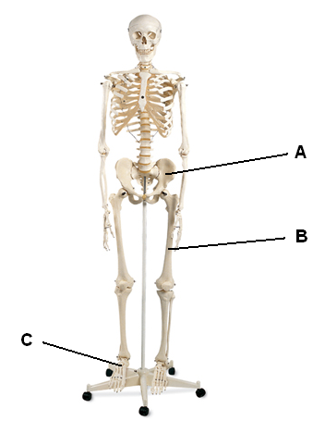

|  |  |
| --- | --- |
|  | How it is adapted for bipedal walking |
| A | Bowl shaped to support abdominal muscles (1)  Broad; acetabula wide apart - contributes to carrying angle / allows weight close to central axis OR  Allow muscle attachment for bipedalism (1) |
| B | Enlarged lateral head / condyle at knee – contributes to carrying angle / allows weight close to central axis (1)  Longer than arms to lower centre of gravity (1) |
| C | **Transverse** and longitudinal arch (1)  Aligned / non-opposable big toe and large calcaneus / heel bone to bear weight (1) |

(6 marks)

**Question 24 (12 marks)**

Use the illustration below to answer part (a). It shows an early hominin skull compared to a modern human skull.

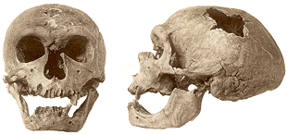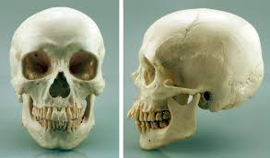

1. Identify and describe THREE evolutionary changes evident between the skulls above and suggest ONE reason for each change. (6 marks)

|  |  |
| --- | --- |
| **Evolutionary Change** | **Reason for Change** |
| Loss of brow ridge | development of forehead/frontal lobe |
| Development of rounded cranium | increased cranial capacity/frontal lobe |
| Increased cranial capacity | increased cerebrum |
| Reduced teeth size | increase in dietary meat |
| Mandible is less robust | decreased teeth size/ bipedal adaptation |
| Reduced prognathism | Decreased olfactory/bipedal adaptation |

1. What are two (2) pieces of evidence that suggests that Neanderthals possessed cultural traits? (2 marks)

* *They made stone tools*
* *Evidence of burial of the dead*
* *Cave art and painting*

c) Which is the oldest? Explain your choice

* *Set 1*
* *They are the simplest/ least work done to them/ Olduwan tools*

(2 marks)

d) What trends in tool development are shown from set 2 to set 6?

* Increase complexity/ work done/ patternation of the tools
* *Increase in the types of tools/ shapes of blades*
* *Increase in the types of materials used to make tools*

(2 marks)

### Section 3: Extended Answer (10 marks)

Answer **one** of the following questions. **DO NOT** answer both.

**Question 21**

During the biological evolution of hominins from the earliest australopithecines to early Homo sapiens, there were significant cultural advances.

Describe the advances made in **tool culture (include manufacture and use)** with reference to the particular hominin groups of Australopithecines, Paranthropus robustus, Homo habilis, Homo erectus and early Homo sapiens. (10 marks)



OR

21. The evolution of hominins can be related to certain physical and cultural advances that improved their survival chances. Describe THREE physical and THREE cultural changes that have characterised hominin evolution, explaining how these advances aided survival.

(10 marks)

* Physical Changes
  + Position of the foramen magnum/ Curvature of the spine/ jaw/ pelvis/carrying angles/knee/foot/centre of gravity
    - Description
    - Explanation of how it has aided survival (MAX 2 from this section)
  + Upright Stance
    - Description
    - Explanation of how it has aided survival
  + Size of cerebral cortex
    - Description
    - Explanation of how it has aided survival
  + Prognathism and dentition
    - Description
    - Explanation of how it has aided survival
* Cultural Changes
  + Tool Use
    - Description
    - Explanation of how it has aided survival
  + Shelters
    - Description
    - Explanation of how it has aided survival
  + Hunter-Gather/ Industrial society
    - Description
    - Explanation of how it has aided survival
  + Art
    - Description
    - Explanation of how it has aided survival
  + Language
    - Description
    - Explanation of how it has aided survival
  + Burial of the dead
    - Description
    - Explanation of how it has aided survival

Max 6 marks for naming of physical and cultural changes. 4 marks for the other points.